**MySQL Data types**

Int Family

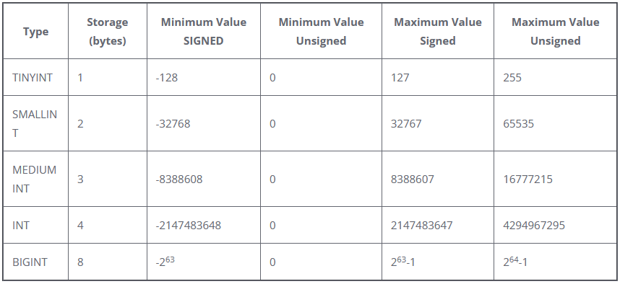

**Float Family**

Float – 4 bytes

Double – 8 bytes

Decimal – Size varies

DateTime Family

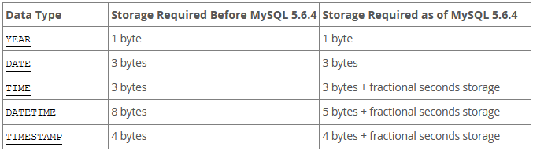

**Datetime** - The DATETIME type is used when you need values that contain both date and time information. MySQL retrieves and displays DATETIME values in 'YYYY-MM-DD HH:MM:SS' format. The supported range is '1000-01-01 00:00:00' to '9999-12-31 23:59:59'.

**Timestamp** - The TIMESTAMP data type has a range of '1970-01-01 00:00:01' UTC to '2038-01-09 03:14:07' UTC. It has varying properties, depending on the MySQL version and the SQL mode the server is running in.

**String Family – (Text)**

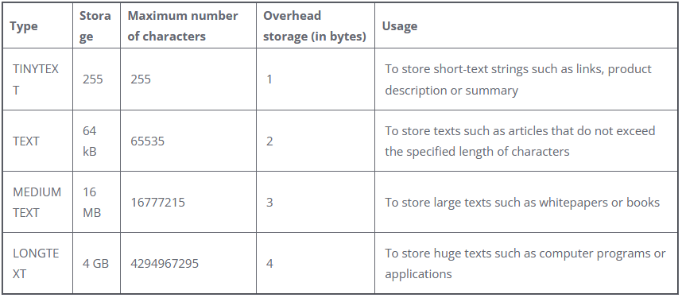

|  |  |
| --- | --- |
| **Data Types** | **Storage** |
| Tinytext | 255 (2 8−1) bytes |
| Text  MediumText | 65,535 (216−1) bytes  16,777,215 (224−1) bytes |
| LongText | 4,294,967,295 (232−1) bytes |